18, Sep., 2016
Addressed to :
Mr. Mohamed Sahr Juanah
Head of Water Resources

Re : REQUEST FOR BOREHOLE DATA FOR NATIONAL GROUNDWATER MAPPING

- Overview of Completed Boreholes by Team & Team

No. | Name of the community | Chiefdom | GPS COORDINATES |  | Total Depth (m) | Water Level (m) | Borehole Yield (m3) | Borehole ID  (Nameplate ID)
No. | Name of the community | Chiefdom | Latitude | Longitude
1 | Mamaso | Maforki PLoko | 8˚43’10”N | 12˚35’04”W | 50 | 14.2 | 5.20 | 2016B0036
2 | Rosint | Maforki PLoko | 8˚47’39”N | 12˚49’20”W | 50 | 14.2 | 6.40 | 2016B0020
3 | Rotifunk Community | Kaffu- Bullom PLoko | 8˚36’14”N | 13˚10’37”W | 45 | 17.5 | 7.30 | To be confirmed
4 | Rotifunk Market | Kaffu- Bullom PLoko | 8˚36’09”N | 13˚10’42”W | 46 | 17.5 | 6.50 | 2016B0019
5 | Gbaneh Bana | Lokomasama PLoko | 8˚40’19”N | 13˚10’40”W | 50 | 22.75 | 6.35 | 2016B0017
6 | Tombo Lol | Lokomasama PLoko | 8˚37’36”N | 13˚10’37”W | 50 | 18.40 | 4.30 | 2016B0018
7 | Masaliya Youth Village | Koya PLoko | 8˚23’08”N | 12˚44’29”W | 50 | 21.50 | 6.80 | 2016B0021
8 | Petifu-Madina | Marampa PLoko | 8˚35’54”N | 12˚44’07”W | 50 | 9.20 | 7.40 | 2016B0022
9 | Kabaya Village | Bramaia Kambia | 9°24’27”N | 12°39’29”W | 42 | 11 | 7.60 | 2016B0031
10 | Kamasasa  Community | Bramaia Kambia | 9°23’38”N | 12°32’32”W | 40 | 14.2 | 5.32 | 2016B0029
11 | Kambia Road | Tonko Limba Kambia | 9°17’03”N | 12°40’18”W | 46 | 10.2 | 6.83 | 2016B0030
12 | Kukuna Central  Mosque | Bramaia Kambia | 9°23’58”N | 12°39’52”W | 45 | 6.2 | 9 | 2016B0033
13 | Komboi | Bramaia Kambia | 9°23’40”N | 12°40’00”W | 49 | 17.5 | 4 | 2016B0032
14 | Kuradara Community | Tonko-Limba Kambia | 9°26’39”N | 12°32’35”W | 52 | 16.8 | 3 | 2016B0028
15 | Madina Town | Tonko-Limba Kambia | 9°17’30”N | 12°40’28”W | 42 | 11 | 3.70 | 2016B0027
16 | Mambolo Town | Mambolo Kambia | 8°55’23”N | 13°02’25”W | 34 | 18.2 | 5.30 | 2016B0025
17 | Royark | Mambolo Kambia | 8°56’01”N | 12°59’49”W | 48 | 17.2 | 5.10 | 2016B0026
18 | Kamba Village | Magbema Kambia | 9°10’32”N | 12°47’40”W | 46 | 6.5 | 5.40 | 2016B0024
- Detail
- Mamaso
Name of the community |  |  | Chiefdom |  | GPS COORDINATES |  |  |  | Total Depth (m) | Water Level (m) | Borehole Yield (m3) | Borehole ID (Nameplate ID)
 |  |  |  |  | Latitude |  | Longitude
Mamaso |  |  | Maforki |  | 8˚43’10’’N |  | 12˚35’04”W |  | 50 | 14.20 | 5.20 | 2016B0036
Formation Log |  |  |  |  |  |  |  | CASINGS PLANNING
No | Start | Finish |  | Meter |  | Formation Remarks
1 | 0945 | 0954 |  | 0-2 |  | Brown soil |  | 50-47m Plain casing  47-41m screen casings  41-35m Plain casings  35-29m Screen casings  29-01m plain casings  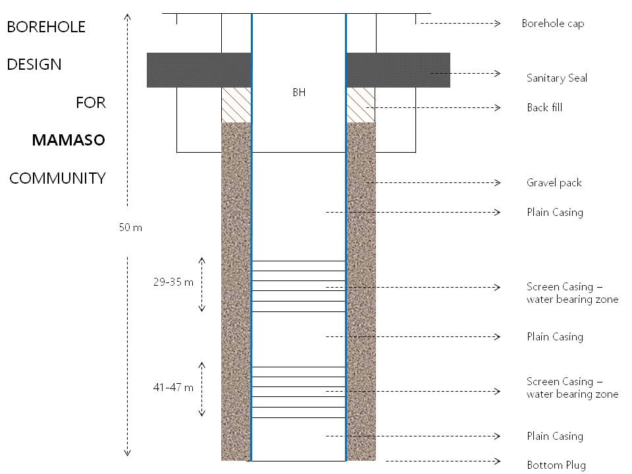
2 | 0954 | 1002 |  | 2-4 |  | Brown soil
3 | 1002 | 1009 |  | 4-6 |  | Brown clay and sand
4 | 1009 | 1017 |  | 6-8 |  | Brown clay
5 | 1017 | 1028 |  | 8-10 |  | Brown clay
6 | 1028 | 1039 |  | 10-12 |  | Brown clay
7 | 1039 | 1048 |  | 12-14 |  | Grain gravel
8 | 1048 | 1119 |  | 14-16 |  | Grain gravel
9 | 1119 | 1140 |  | 16-18 |  | Boulders
10 | 1140 | 1220 |  | 18-20 |  | Aquifer zone
11 | 1220 | 1259 |  | 20-22 |  | Igneous rock
12 | 13 30 | 1415 |  | 22-24 |  | Igneous rock
13 | 1415 | 1448 |  | 24-26 |  | Ingenious rock
14 | 1448 | 1550 |  | 26-28 |  | Igneous rock
15 | 1550 | 1640 |  | 28-30 |  | Igneous rock
16 | 1640 | 1739 |  | 30-32 |  | Aquifer zone
17 | 1739 | 1831 |  | 32-34 |  | Aquifer zone
18 | 1831 | 1921 |  | 34-34 |  | Igneous rock
19 | 1921 | 2017 |  | 34-40 |  | Aquifer zone
20 | 1020 | 1530 |  | 40-45 |  | Igneous rock
21 |  |  |  | 45--50 |  | Igneous rock
- Rosint
Name of the community |  |  | Chiefdom |  | GPS COORDINATES |  |  |  | Total Depth (m) | Water Level (m) | Borehole Yield (m3) | Borehole ID (Nameplate ID)
 |  |  |  |  | Latitude |  | Longitude
Rosint |  |  | Maforki |  | 8˚47’39’’N |  | 12˚49’20’’W |  | 50 | 14.20 | 6.40 | 2016B0020
Formation Log |  |  |  |  |  |  |  | CASINGS PLANNING
No | Start | Finish |  | Meter |  | Formation Remarks
1 | 15:20 | 15:26 |  | 0-2 |  | Brown Murom soil |  | 50-45m Plain casing  45-39m screen casings  39-33m Plain casings  33-27m Screen casings  27-01m plain casings  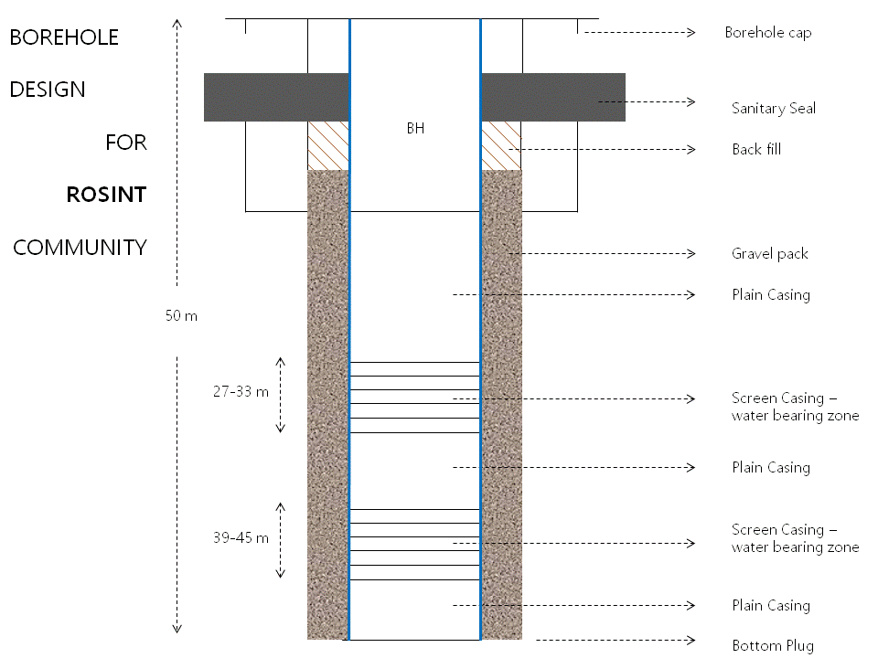
2 | 15:26 | 15:37 |  | 4-6 |  | Brown Murom soil
3 | 15:37 | 15:47 |  | 6-8 |  | Brown sand deposit
4 | 15:47 | 16:02 |  | 8-10 |  | Brown sand deposit
5 | 16:02 | 16:14 |  | 10-12 |  | Brown clay and sand
6 | 16:14 | 16:28 |  | 12-14 |  | Brownish sand deposit
7 | 16:28 | 16:44 |  | 14-16 |  | Brown sand Deposit
8 | 16:44 | 17:01 |  | 16-18 |  | Partially weathered zone
9 | 17:01 | 17:20 |  | 18-20 |  | Weathered zone
10 | 08:30 | 08:50 |  | 20-22 |  | Weathered zone
11 | 08:50 | 09:20 |  | 22-24 |  | Fresh granite rock
12 | 09:20 | 09:35 |  | 24-26 |  | Fresh granite rock
13 | 09:35 | 09:55 |  | 26-28 |  | Granite rock
14 | 09:55 | 1019 |  | 28-30 |  | Granite rock
15 | 10:19 | 10:40 |  | 30-32 |  | Granite rock
16 | 10:40 | 11:20 |  | 32-34 |  | Granite rock
17 | 11:20 | 11: 42 |  | 34-36 |  | Water Bearing zone
18 | 11:42 | 12.15 |  | 36-38 |  | Fractured rock
19 | 12:15 | 12:57 |  | 38-40 |  | Water bearing Zone
20 | 14:20 | 14:30 |  | 40-45 |  | Granite rock
21 | 14:50 | 15:18 |  | 45-50 |  | Granite rock
- Rotifunk Community
Name of the community |  |  | Chiefdom |  | GPS COORDINATES |  |  |  | Total Depth (m) | Water Level (m) | Borehole Yield (m3) | Borehole ID (Nameplate ID)
 |  |  |  |  | Latitude |  | Longitude
Rotifunk Community |  |  | Kaffu- Bullom |  | 8˚36’14’’N |  | 13˚10’37’’W |  | 45 | 17.50 | 7.30
Formation Log |  |  |  |  |  |  |  | CASINGS PLANNING
No | Start | Finish |  | Meter |  | Formation Remarks
1 | 1320 | 1324 |  | 0-2 |  | Brown Clay deposit |  | 45-40m - plain casings  40-38m - screen casings  38-34m - plain casings  34-26m - screen casing  26-01m - plain casing  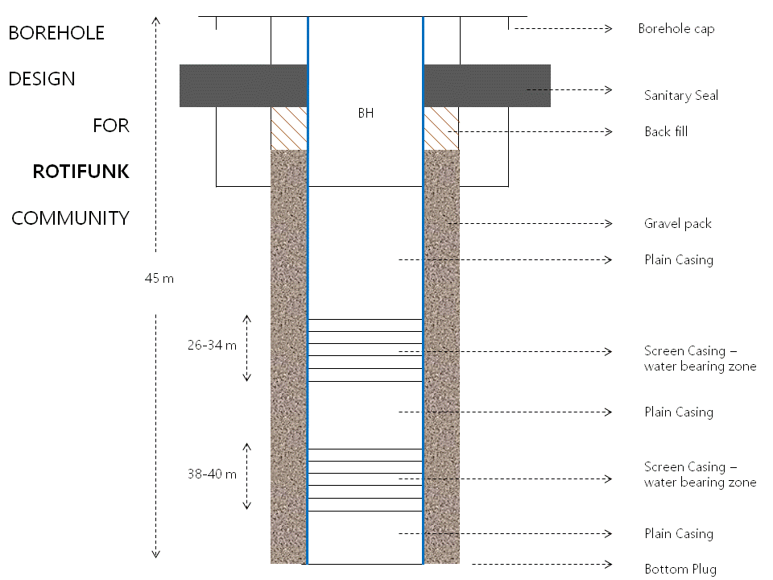
2 | 1324 | 1329 |  | 2-4 |  | Brown clay deposit
3 | 1329 | 1336 |  | 6-8 |  | Brown Clay deposit
4 | 1336 | 1340 |  | 8-10 |  | Brown clay and sand deposit
5 | 1340 | 1344 |  | 10-12 |  | Brown clay and sand deposit
6 | 1344 | 1350 |  | 12-14 |  | Fine brown sand
7 | 1350 | 1359 |  | 14-16 |  | Fine brown sand
8 | 1359 | 1407 |  | 16-18 |  | Fine brown sand
9 | 1407 | 1420 |  | 18-20 |  | Fine brown sand
10 | 1545 | 1552 |  | 20-22 |  | Fine brown sand
11 | 1552 | 1559 |  | 22-24 |  | Fine brown sand
12 | 1559 | 1604 |  | 24-26 |  | Fine brown sand
13 | 1604 | 1614 |  | 26-28 |  | Fine brown sand
14 | 1614 | 1620 |  | 28-30 |  | Partially weathered
15 | 1620 | 1630 |  | 30-32 |  | Grain sand
16 | 1630 | 1640 |  | 32-34 |  | Grain sand
17 | 1640 | 1709 |  | 34-36 |  | Alluvial sand deposit
18 | 0815 | 0830 |  | 36-38 |  | water bearing zone
19 | 0830 | 0839 |  | 38-40 |  | Water bearing
20 | 1039 | 10 53 |  | 40-45 |  | Alluvial clay and grain sand
21 | 1053 | 1122 |  | 45-50 |  | Alluvial clay
- Rotifunk Market
Name of the community |  |  | Chiefdom |  |  | GPS COORDINATES |  |  | Total Depth (m) | Water Level (m) | Borehole Yield (m3) | Borehole ID (Nameplate ID)
 |  |  |  |  |  | Latitude | Longitude
Rotifunk Market |  |  | Kaffu- Bullom |  |  | 8˚36’09’’N | 13˚10’42’’W |  | 46 | 17.50 | 6.50 | 2016B0019
Formation Log |  |  |  |  |  |  |  | CASINGS PLANNING
No | Start | Finish |  | Meter | Formation Remarks
1 | 1420 | 1424 |  | 0-2 | Brown clay |  |  | 46m-43m plain casings  43m-37m Screen casings  37m-31m plain casings  31m-25m screen casings  25m-01m plain casing  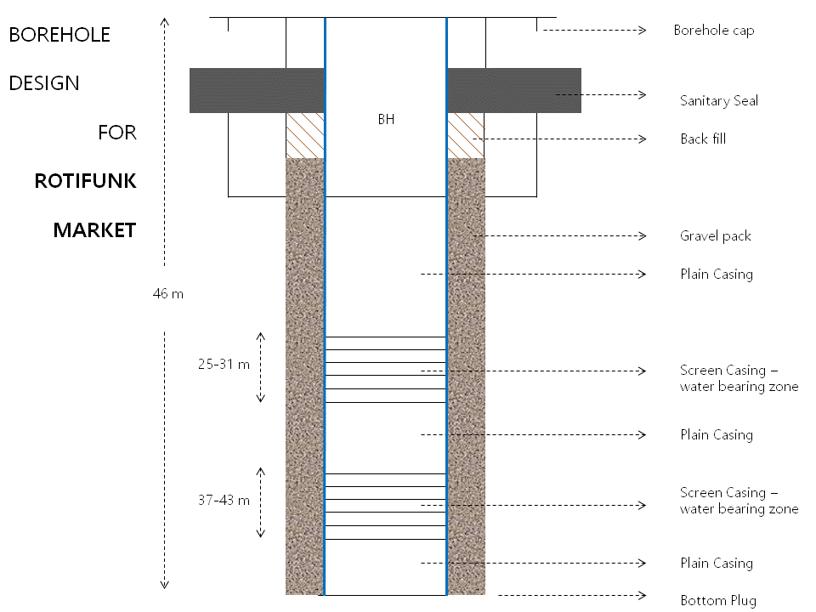
2 | 1424 | 1429 |  | 2-4 | Brown clay
3 | 1429 | 1435 |  | 6-8 | Brownish sand and clay
4 | 1435 | 1442 |  | 8-10 | Fine brown sand
5 | 1442 | 1450 |  | 10-12 | Alluvial clay
6 | 1450 | 1502 |  | 12-14 | Alluvial clay
7 | 1502 | 1508 |  | 14-16 | Fine brown sand
8 | 1508 | 1517 |  | 16-18 | Fine brown sand
9 | 1517 | 1523 |  | 18-20 | Fine brown sand
10 | 1523 | 1532 |  | 20-22 | Fine brown sand
11 | 1532 | 1543 |  | 22-24 | Sand and clay deposits
12 | 1543 | 1557 |  | 24-26 | Sand and clay deposits
13 | 1557 | 1609 |  | 26-28 | Grain gravel
14 | 1609 | 1622 |  | 28-30 | aquifer
15 | 1622 | 1635 |  | 30-32 | Fine sand deposit
16 | 1635 | Stopped |  | 32-34 | Fine grain gravel
17 | 0811 | 0823 |  | 34-36 | Grain gravel
18 | 0823 | 0836 |  | 36-40 | Grain gravel
19 | 0836 | 0850 |  | 40-45 | Alluvial clay
20 | 0850 | 0908 |  | 45-46 | alluvial clay
- Gbaneh Bana
Name of the community |  |  | Chiefdom |  |  | GPS COORDINATES |  |  | Total Depth (m) | Water Level (m) | Borehole Yield (m3) | Borehole ID (Nameplate ID)
 |  |  |  |  |  | Latitude | Longitude
Gbaneh Bana |  |  | Lokomasama |  |  | 8˚40’19”N | 13˚10’40”W |  | 50 | 22.75 | 6.35 | 2016B0017
Formation Log |  |  |  |  |  |  |  | CASINGS PLANNING
No | Start | Finish |  | Meter | Formation Remarks
1 | 1017 | 1026 |  | 0-2 | Brownish clay deposit |  |  | 50-47 Plain casings  47-41 Screen casings  41-35 Plain Casings  35-29 Screen casings  29-01 Plain Casings  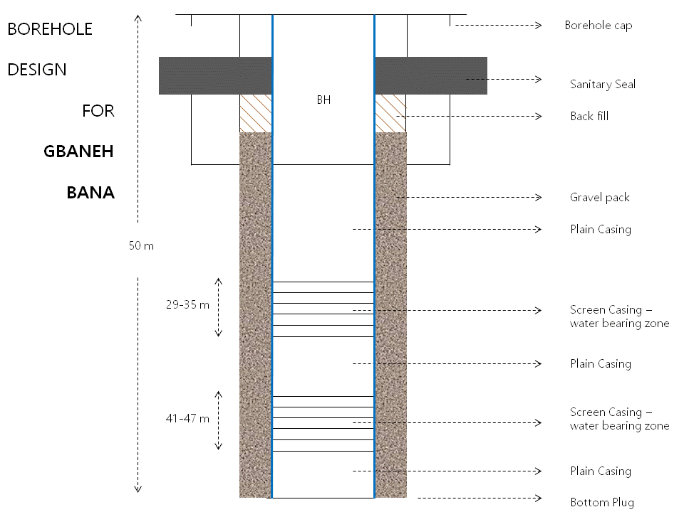
2 | 1026 | 1038 |  | 2-4 | Brownish clay and sand
3 | 1038 | 1053 |  | 4-6 | Brownish sand deposit
4 | 1053 | 1112 |  | 6-8 | Brownish sand deposit
5 | 1112 | 1129 |  | 8-10 | Brownish fine sand
6 | 1129 | 1149 |  | 10-12 | Coarse sand deposit
7 | 1149 | 1205 |  | 12-14 | Coarse sand deposit
8 | 1205 | 1223 |  | 14-16 | Slightly weathered Zone
9 | 1223 | 1234 |  | 16-18 | Coarse sand clay deposit
10 | 1234 | 1252 |  | 18-20 | Coarse sand and Clay Deposit
11 | 1252 | 1314 |  | 20-22 | Slightly Weather
12 | 1314 | 1328 |  | 22-24 | Aquifer zone
13 | 1328 | 1345 |  | 24-26 | Fine grayish sand
14 | 1345 | 1402 |  | 26-28 | Fine grayish sand
15 | 1402 | 1427 |  | 28-30 | Fine grayish sand
16 | 1427 | 1449 |  | 30-32 | Aquifer bearing zone
17 | 1449 | 1458 |  | 32-34 | Coarse Sand deposit
18 | 1458 | 1521 |  | 34-36 | Coarse Sand deposit
19 | 1521 | 1543 |  | 35-40 | Aquifer bearing zone
20 | 1543 | 1610 |  | 40-45 | Alluvial clay and sand deposit
21 | 1610 | 1633 |  | 45-50 | Alluvial Clay deposited
- Tombo Lol
Name of the community |  |  | Chiefdom |  |  | GPS COORDINATES |  |  | Total Depth (m) | Water Level (m) | Borehole Yield (m3) | Borehole ID (Nameplate ID)
 |  |  |  |  |  | Latitude | Longitude
Tombo Lol |  |  | Lokomasama |  |  | 8˚37’36’’N | 13˚10’37’’W |  | 50 | 18.40 | 4.30 | 2016B0018
Formation Log |  |  |  |  |  |  |  | CASINGS PLANNING
No | Start | Finish |  | Meter | Formation Remarks
1 | 1022 | 1029 |  | 0-2 | Brown soil sand |  |  | 50-47 Plain casings  47-41 Screen casings  41-35 Plain casings  35-29 Screen casing  29-01 Plain casing  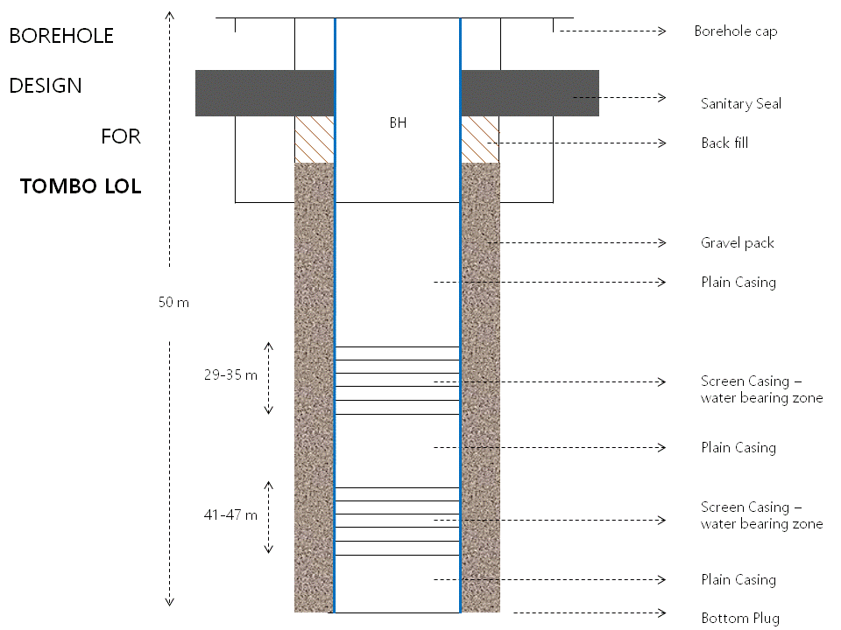
2 | 1029 | 1038 |  | 2-4 | Brown soil sand
3 | 1038 | 1047 |  | 4-6 | Brown sand deposits
4 | 1047 | 1102 |  | 6-8 | Brown sand deposits
5 | 1102 | 1119 |  | 8-10 | Brown fine sand
6 | 1119 | 1138 |  | 10-12 | Grayish fine sand
7 | 1138 | 1152 |  | 12-14 | Grayish fine sand
8 | 1152 | 1209 |  | 14-16 | Grayish fine sand
9 | 1209 | 1227 |  | 16-18 | Grayish fine sand
10 | 1227 | 1241 |  | 18-20
11 | 1241 | 1255 |  | 20-22 | Slightly weathered
12 | 1255 | 1314 |  | 22-24 | Slightly weathered
13 | 1314 | 1325 |  | 24-26 | Grayish fine sand
14 | 1325 | 1337 |  | 26-28 | Grayish fine sand
15 | 1337 | 1349 |  | 28-30 | Aquifer bearing zone
16 | 1349 | 1406 |  | 30-32
17 | 1406 | 1427 |  | 32-34
18 | 1427 | 1442 |  | 34-36 | Aquifer bearing zone
19 | 1442 | 1504 |  | 36-40 | Aquifer bearing zone
20 | 1504 | 1702 |  | 40-45 | Coarse sand deposits
21 | 0838 | 0853 |  | 45-50 | Alluvial stiff clay

- Masaliya Youth Village
Name of the community |  |  | Chiefdom |  |  | GPS COORDINATES |  |  | Total Depth (m) | Water Level (m) | Borehole Yield (m3) | Borehole ID (Nameplate ID)
 |  |  |  |  |  | Latitude | Longitude
Masaliya Youth Village |  |  | Koya |  |  | 8˚23’08’’N | 12˚44’29’’W |  | 50 | 21.50 | 6.80 | 2016B0021
Formation Log |  |  |  |  |  |  |  | CASINGS PLANNING
No | Start | Finish |  | Meter | Formation Remarks
1 | 0930 | 0940 |  | 0-2 | Brown clay soil |  |  | 50-47 Plain casings  47-41 Screen casings  41-35 Plain casings  35-29 Screen casing  29-01 Plain casing
2 | 0940 | 0949 |  | 2-4 | Brown clay soil
3 | 0949 | 0957 |  | 4-6 | Brown clay and sand
4 | 0957 | 1013 |  | 6-8 | Brown sand deposit
5 | 1013 | 1030 |  | 8-10 | Brown sand deposit
6 | 1030 | 1042 |  | 10-12 | Brownish fine sand
7 | 1042 | 1056 |  | 12-14 | Brownish fine sand
8 | 1056 | 1119 |  | 14-16 | Brownish fine sand and clay
9 | 1119 | 1138 |  | 16-18 | Brownish fine sand deposit
10 | 1138 | 1155 |  | 18-20 | Brownish fine sand
11 | 1155 | 1217 |  | 20-22 | clay deposit
12 | 1217 | 1231 |  | 22-24 | clay deposit and sand
13 | 1231 | 1244 |  | 24-26 | Sand deposits
14 | 1407 | 1429 |  | 26-28 | weathered stone
15 | 1429 | 1451 |  | 28-30 | Aquifer bearing zone
16 | 1451 | 1522 |  | 30-32 | sedimentary formation
17 | 1522 | 1551 |  | 32-34 | consolidated /unconsolidated
18 | 0821 | 0849 |  | 34-36 | Consolidated /unconsolidated
19 | 0849 | 0906 |  | 36-38 | Volcanic rock
20 | 0906 | 1415 |  | 40-45 | Aquifer bearing zone
21 | 1415 | 1440 |  | 45-50 | volcanic rock
- Petifu-Madina
Name of the community |  |  | Chiefdom |  |  | GPS COORDINATES |  |  | Total Depth (m) | Water Level (m) | Borehole Yield (m3) | Borehole ID (Nameplate ID)
 |  |  |  |  |  | Latitude | Longitude
Petifu-Madina |  |  | Marampa |  |  | 8˚35’54’’N | 12˚44’07’’W |  | 50 | 9.20 | 7.40 | 2016B0022
Formation Log |  |  |  |  |  |  |  | CASINGS PLANNING
No | Start | Finish |  | Meter | Formation Remarks
1 | 1520 | 1529 |  | 0-2 | Brown clay soil |  |  | 50-46 - 1/2 Plain casings  46-37 - Screen casings  37-34 - Plain casings  34-31 - Screen casings  31-01 - plain casings  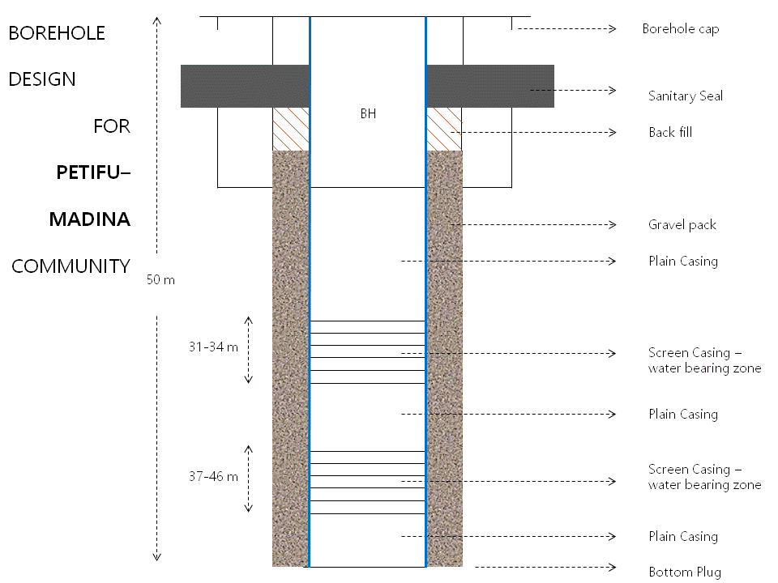
2 | 1529 | 1538 |  | 2-4 | Brown clay soil
3 | 1538 | 1550 |  | 4-6 | Brown soil and gravel
4 | 1550 | 1603 |  | 6-8 | Granite rock
5 | 1603 | 1617 |  | 8-10 | Granite rock
6 | 1617 | 1629 |  | 10-12 | Granite rock
7 | 1629 | 1644 |  | 12-14 | Granite rock
8 | 1644 | 1659 |  | 14-16 | Slightly weathered
9 | 1659 | 1712 |  | 16-18 | Slightly weathered
10 | 0821 | 0841 |  | 18-20 | Granite rock
11 | 0831 | 0913 |  | 20-22 | Granite rock
12 | 0913 | 0941 |  | 22-24 | Granite rock
13 | 0941 | 1008 |  | 24-26 | Granite rock
14 | 1008 | 1031 |  | 26-28 | Granite rock
15 | 1031 | 1055 |  | 28-30 | Granite rock
16 | 1055 | 1123 |  | 30-32 | Aquifer bearing zone
17 | 1123 | 1150 |  | 32-34 | Fractured zone
18 | 1150 | 1217 |  | 34-36 | Fractured zone
19 | 1217 | 1245 |  | 36-38 | Aquifer bearing zone
20 | 1245 | 1304 |  | 38-40 | Granite rock
21 | 1304 | 1340 |  | 40-50 | Granite rock
- Kabaya Village
Name of the community |  |  | Chiefdom |  |  | GPS COORDINATES |  |  | Total Depth (m) | Water Level (m) | Borehole Yield (m3) | Borehole ID (Nameplate ID)
 |  |  |  |  |  | Latitude | Longitude
Kabaya Village |  |  | Brimaia |  |  | 9°24’27”N | 12°39’29”W |  | 42m | 11m | 7.60m³ | 2016B0031
Formation Log |  |  |  |  |  |  |  | CASINGS PLANNING
No | Start | Finish |  | Meter | Formation Remarks
1 | 1539 | 1542 |  | 0-2 | Brown soil |  |  | 42m-39m Plain casing  39m-33m screen casings  33m-27m Plain casings  27m-21m Screen casings  21m-01m plain casings  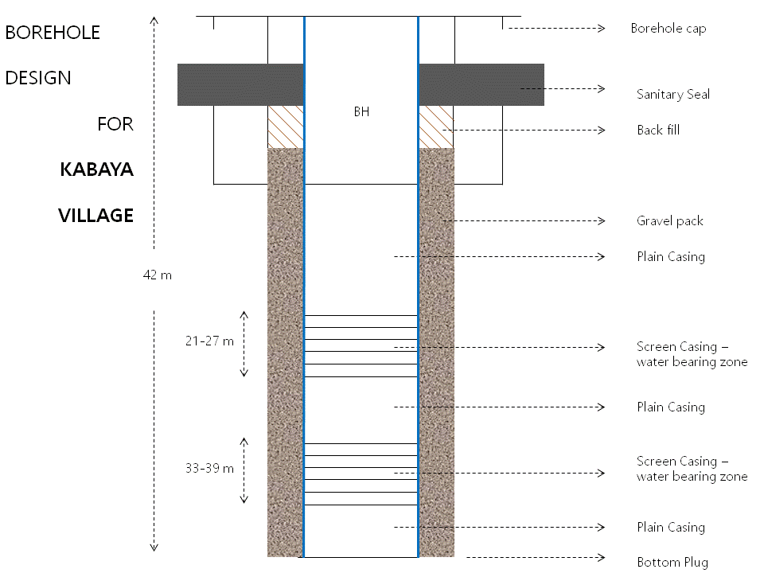
2 | 1542 | 1546 |  | 2-4 | Brown soil
3 | 1546 | 1556 |  | 4-6 | Brown clay and sand
4 | 1556 | 1604 |  | 6-8 | Brown clay
5 | 1604 | 1614 |  | 8-10 | Brown clay
6 | 1614 | 1636 |  | 10-12 | Brown clay
7 | 1636 | 1720 |  | 12-14 | Grain gravel
8 | 1006 | 1041 |  | 14-16 | Grain gravel
9 | 1041 | 1119 |  | 16-18 | Fine brown sand
10 | 1119 | 1158 |  | 18-20 | Fine brown sand
11 | 1158 | 1222 |  | 20-22 | Slightly weathered
12 | 1222 | 1241 |  | 22-24 | Aquifer bearing
13 | 1241 | 1312 |  | 24-26 | Aquifer bearing
14 | 1312 | 1339 |  | 26-28 | Grain sand / clay
15 | 1339 | 1359 |  | 28-30 | Grain sand / clay
16 | 1359 | 1414 |  | 30-32 | Grain sand / clay
17 | 1414 | 1439 |  | 32-34 | Grain brown sand
18 | 1439 | 14 59 |  | 34-34 | Aquifer bearing
19 | 1459 | 1516 |  | 34-36 | Stiff clay deposits
20 | 1516 | 1534 |  | 40-42 | Stiff clay deposits
- Kamasasa Community Village
Name of the community |  |  | Chiefdom |  |  | GPS COORDINATES |  |  | Total Depth (m) | Water Level (m) | Borehole Yield (m3) | Borehole ID (Nameplate ID)
 |  |  |  |  |  | Latitude | Longitude
Kamasasa Community Village |  |  | Brimaia |  |  | 9°23’38” N | 12°32’32” W |  | 40m | 14.2m | 5.32m³ | 2016B0029
Formation Log |  |  |  |  |  |  |  | CASINGS PLANNING
No | Start | Finish |  | Meter | Formation Remarks
1 | 0948 | 0954 |  | 0-2 | Brown soil |  |  | 40 -37 m –Plain casing  37 - 25 m – screen casing  25- 01 m –plain casings  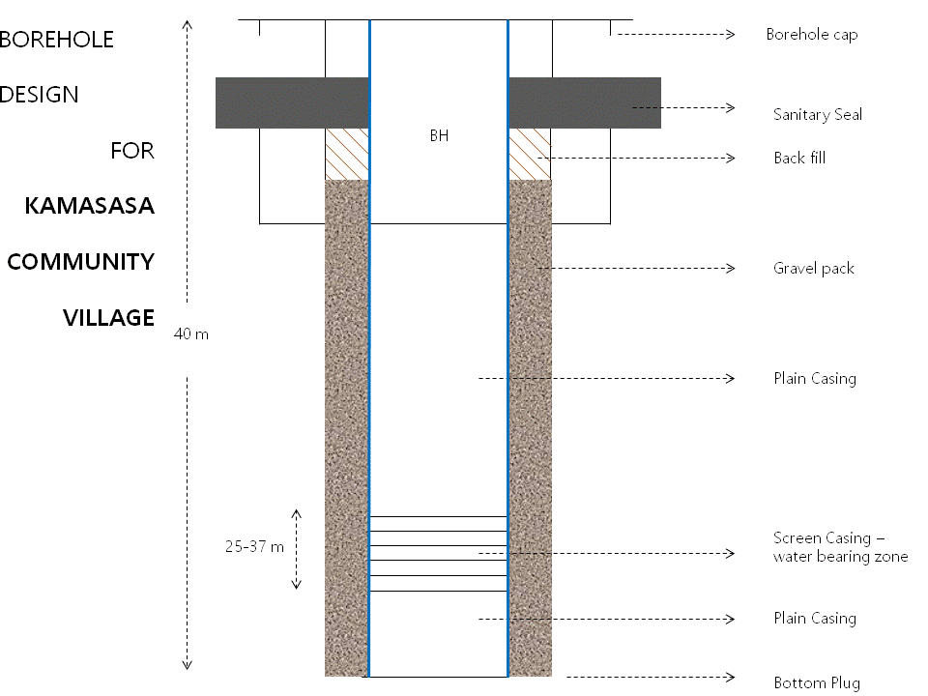
2 | 0954 | 1002 |  | 2-4 | Brown soil
3 | 1002 | 1009 |  | 4-6 | Brown clay and sand
4 | 1009 | 1017 |  | 6-8 | Brown clay
5 | 1017 | 1028 |  | 8-10 | Brown clay
6 | 1028 | 1039 |  | 10-12 | Brown clay
7 | 1039 | 1048 |  | 12-14 | Grain gravel
8 | 1048 | 1119 |  | 14-16 | Grain gravel
9 | 1119 | 1140 |  | 16-18 | Alluvial sand deposit
10 | 1140 | 1220 |  | 18-20 | Alluvial sand deposit
11 | 1220 | 1259 |  | 20-22 | Slightly weathered
12 | 13 30 | 1415 |  | 22-24 | Slightly weathered
13 | 1415 | 1448 |  | 24-26 | Coarse sand
14 | 1448 | 1550 |  | 26-28 | Coarse sand
15 | 1550 | 1640 |  | 28-30 | Aquifer bearing zone
16 | 1640 | 1739 |  | 30-32 | Weathered rock
17 | 1739 | 1831 |  | 32-34 | Weathered rock
18 | 09 30 | 0945 |  | 34-34 | Aquifer bearing zone
19 | 0945 | 1013 |  | 34-40 | Weathered rock
- Kambia Road
Name of the community |  |  | Chiefdom |  |  | GPS COORDINATES |  |  | Total Depth (m) | Water Level (m) | Borehole Yield (m3) | Borehole ID (Nameplate ID)
 |  |  |  |  |  | Latitude | Longitude
Kambia Road |  |  | Tonko Limba |  |  | 9°17’03” N | 12°40’18” W |  | 46m | 10.2m | 6.83m³ | 2016B0030
Formation Log |  |  |  |  |  |  |  | CASINGS PLANNING
No | Start | Finish |  | Meter | Formation Remarks
1 | 0820 | 0824 |  | 0-2 | Brown soil |  |  | 46 - 42m plain casings  42 - 36m screen casings  36 - 27m plain casings  27 - 21m screen casings  21 - 01m plain casings  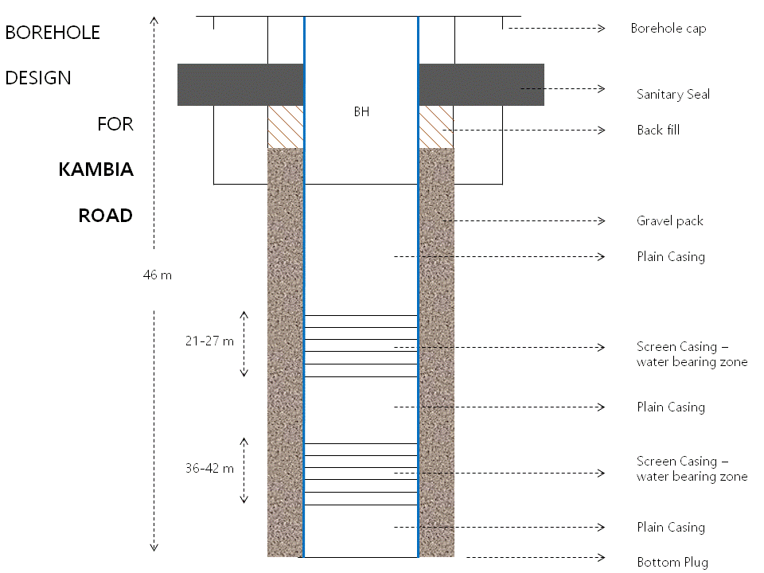
2 | 0824 | 0829 |  | 2-4 | Brown soil
3 | 0829 | 0837 |  | 4-6 | Brown clay and sand
4 | 0837 | 0855 |  | 6-8 | Brown clay
5 | 0855 | 0912 |  | 8-10 | Brown clay
6 | 0912 | 0921 |  | 10-12 | Fine brown sand
7 | 0921 | 0935 |  | 12-14 | Sand stone
8 | 0935 | 1017 |  | 14-16 | Igneous rock
9 | 1119 | 1140 |  | 16-18 | Weathered zone
10 | 1140 | 1220 |  | 18-20 | Aquifer zone
11 | 1220 | 1259 |  | 20-22 | Aquifer zone
12 | 1259 | 1327 |  | 22-24 | Aquifer bearing zone
13 | 1327 | 1351 |  | 24-26 | Solicitous sand
14 | 1351 | 1425 |  | 26-28 | Weathered zone
15 | 1425 | 1456 |  | 28-30 | Highly fractured zone
16 | 1456 | 1523 |  | 30-32 | Highly fractured zone
17 | 1523 | Stopped;  rain |  | 32-34 | Igneous rock
18 | 0913 | 09 31 |  | 34-36 | Igneous rock
19 | 0931 | 0950 |  | 36-38 | Aquifer zone
20 | 1020 | 1054 |  | 38-40 | Igneous rock
21 | 1054 | 1430 |  | 40-46 | Igneous rock
- Kukuna Central Mosque
Name of the community |  |  | Chiefdom |  |  | GPS COORDINATES |  |  | Total Depth (m) | Water Level (m) | Borehole Yield (m3) | Borehole ID (Nameplate ID)
 |  |  |  |  |  | Latitude | Longitude
Kukuna Central Mosque |  |  | Brimaia |  |  | 9°23’58” N | 12°39’52” W |  | 45m | 6.20m | 9.00m³ | 2016B0033
Formation Log |  |  |  |  |  |  |  | CASINGS PLANNING
No | Start | Finish |  | Meter | Formation Remarks
1 | 0942 | 0954 |  | 0-2 | Brown soil |  |  | 45m - 41m Plain casing  41m - 39m screen casings  39m - 36m Plain casings  36m - 30m Screen casings  30m - 23m plain casings  23m -20m screen casing  20m -01m plain casing  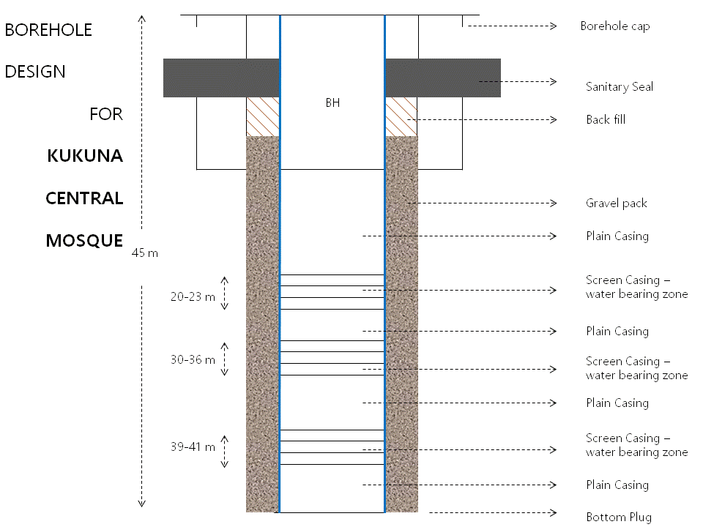
2 | 0954 | 1002 |  | 2-4 | Brown soil
3 | 1002 | 1009 |  | 4-6 | Brown clay and sand
4 | 1009 | 1017 |  | 6-8 | Brown clay
5 | 1017 | 1028 |  | 8-10 | Brown clay
6 | 1028 | 1039 |  | 10-12 | Brown clay
7 | 1039 | 1048 |  | 12-14 | Grain gravel
8 | 1048 | 1119 |  | 14-16 | Grain gravel
9 | 1119 | 1140 |  | 16-18 | Grey coral stone
10 | 1140 | 1220 |  | 18-20 | Grey coral stone
11 | 1220 | 1259 |  | 20-22 | Aquifer bearing zone
12 | 13 30 | 1415 |  | 22-24 | Greyish Coral stone
13 | 1415 | 1448 |  | 24-26 | Greyish coral stone
14 | 1448 | 1550 |  | 26-28 | Greyish coral stone
15 | 1550 | 1640 |  | 28-30 | Greyish coral stone
16 | 1640 | 1739 |  | 30-32 | Aquifer zone
17 | 1739 | 1831 |  | 32-34 | Aquifer zone
18 | 1831 | 1921 |  | 34-34 | Greyish coral stone
19 | 1921 | 2017 |  | 34-40 | Aquifer zone
20 | 1020 | 1530 |  | 40-45 | Greyish coral stone
- Komboi
Name of the community |  |  | Chiefdom |  |  | GPS COORDINATES |  |  | Total Depth (m) | Water Level (m) | Borehole Yield (m3) | Borehole ID (Nameplate ID)
 |  |  |  |  |  | Latitude | Longitude
Komboi |  |  | Brimaia |  |  | 9°23’40” N | 12°40’00” W |  | 49m | 17.5m | 4.00m³ | 2016B0032
Formation Log |  |  |  |  |  |  |  | CASINGS PLANNING
No | Start | Finish |  | Meter | Formation Remarks
1 | 0945 | 0954 |  | 0-2 | Brown soil |  |  | 49 - 46m Plain casing  46 - 40m screen casings  40 - 34m Plain casings  34 - 28m Screen casings  28 - 01m plain casings  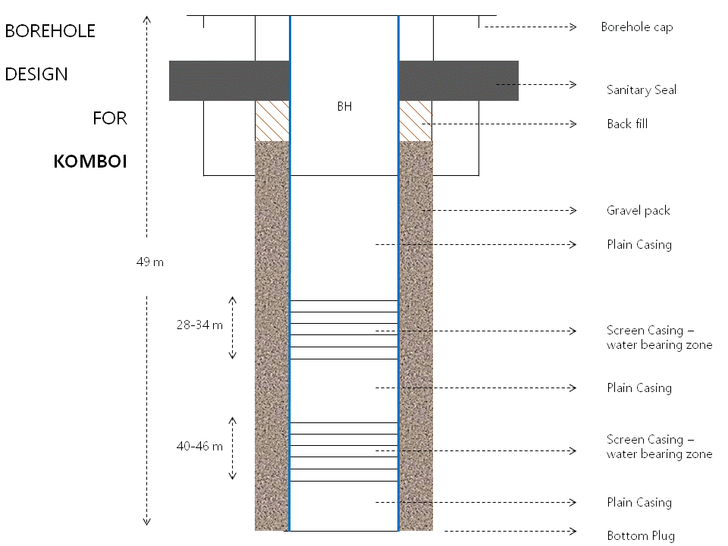
2 | 0954 | 1002 |  | 2-4 | Brown soil
3 | 1002 | 1009 |  | 4-6 | Brown clay and sand
4 | 1009 | 1017 |  | 6-8 | Brown clay
5 | 1017 | 1028 |  | 8-10 | Brown clay
6 | 1028 | 1039 |  | 10-12 | Brown clay
7 | 1039 | 1048 |  | 12-14 | Grain gravel
8 | 1048 | 1119 |  | 14-16 | Grain gravel
9 | 1119 | 1140 |  | 16-18 | Slightly weathered zone
10 | 1140 | 1220 |  | 18-20 | Mud stone
11 | 1220 | 1259 |  | 20-22 | Aquifer bearing zone
12 | 13 30 | 1415 |  | 22-24 | Greyish mudstone
13 | 1415 | 1448 |  | 24-26 | Dyke deposits
14 | 1448 | 1550 |  | 26-28 | Dyke deposits
15 | 1550 | 1640 |  | 28-30 | Dyke deposit
16 | 1640 | 1739 |  | 30-32 | Aquifer zone
17 | 1739 | 1831 |  | 32-34 | Aquifer zone
18 | 1831 | 1921 |  | 34-34 | Dyke stone
19 | 1921 | 2017 |  | 34-40 | Aquifer zone
20 | 1020 | 1530 |  | 40-45 | Dyke deposits
- Kuradara Community
Name of the community |  |  | Chiefdom |  |  | GPS COORDINATES |  |  | Total Depth (m) | Water Level (m) | Borehole Yield (m3) | Borehole ID (Nameplate ID)
 |  |  |  |  |  | Latitude | Longitude
Kuradara Community |  |  | Tonko-Limba |  |  | 9°26’39”N | 12°32’35”W |  | 52m | 16.8m | 3.00m³ | 2016B0028
Formation Log |  |  |  |  |  |  |  | CASINGS PLANNING
No | Start | Finish |  | Meter | Formation Remarks
1 | 1002 | 1007 |  | 0-2 | Brown soil |  |  | 52m - 40m Plain casing  40m - 30m screen casings  30m - 20m Plain casings  20m - 18m Screen casings  18m - 01m plain casings  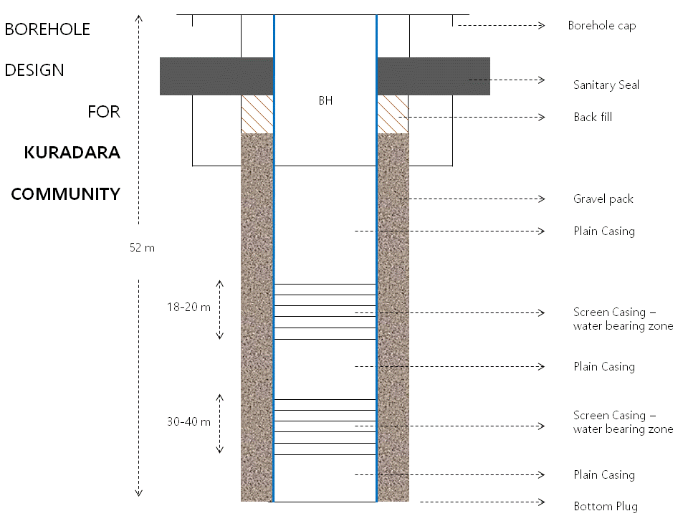
2 | 1007 | 1012 |  | 2-4 | Brown soil
3 | 1012 | 1019 |  | 4-6 | Brown clay and sand
4 | 1019 | 1022 |  | 6-8 | Brown clay
5 | 1022 | 1028 |  | 8-10 | Brown clay
6 | 1028 | 1039 |  | 10-12 | Brown clay
7 | 1039 | 1048 |  | 12-14 | Grain gravel
8 | 1048 | 1119 |  | 14-16 | Grain gravel
9 | 1119 | 1140 |  | 16-18 | Polders
10 | 1140 | 1220 |  | 18-20 | Aquifer zone
11 | 1220 | 1259 |  | 20-22 | Igneous rock
12 | 13 30 | 1415 |  | 22-24 | Igneous rock
13 | 1415 | 1448 |  | 24-26 | Ingenious rock
14 | 1448 | 1550 |  | 26-28 | Igneous rock
15 | 1550 | 1640 |  | 28-30 | Igneous rock
16 | 1640 | 1739 |  | 30-32 | Aquifer zone
17 | 1739 | 1831 |  | 32-34 | Aquifer zone
18 | 1831 | 1921 |  | 34-34 | Igneous rock
19 | 1921 | 2017 |  | 34-40 | Aquifer zone
20 | 1020 | 1530 |  | 40-45 | Igneous rock
21 |  |  |  | 45--52 | Igneous rock
- Madina Town
Name of the community |  |  | Chiefdom |  |  | GPS COORDINATES |  |  | Total Depth (m) | Water Level (m) | Borehole Yield (m3) | Borehole ID (Nameplate ID)
 |  |  |  |  |  | Latitude | Longitude
Madina Town |  |  | Tonko-Limba |  |  | 9°17’30” N | 12°40’28” W |  | 42m | 11m | 3.70m³ | 2016B0027
Formation Log |  |  |  |  |  |  |  | CASINGS PLANNING
No | Start | Finish |  | Meter | Formation Remarks
1 | 0839 | 0842 |  | 0-2 | Brown soil |  |  | 42m to 36 m plain casings  36m to 28 m screen casings  28 m to 01 m plain casings  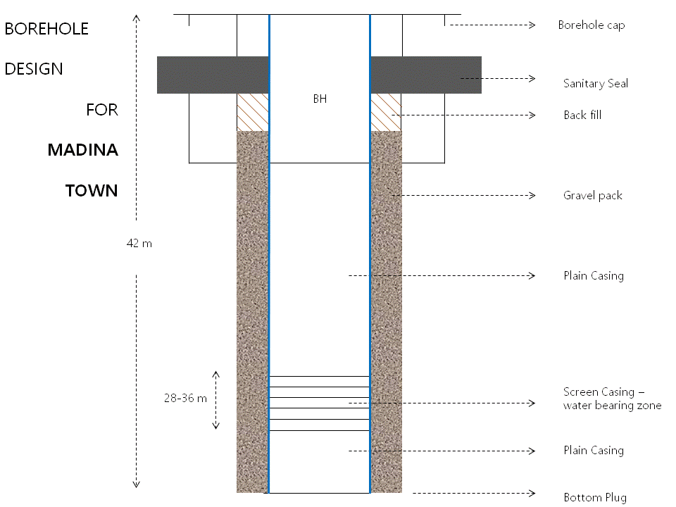
2 | 0842 | 0901 |  | 2-4 | Brown soil
3 | 1002 | 1009 |  | 4-6 | Brown clay and sand
4 | 1009 | 1017 |  | 6-8 | Brown clay
5 | 1017 | 1028 |  | 8-10 | Brown clay
6 | 1028 | 1039 |  | 10-12 | Brown clay
7 | 1039 | 1048 |  | 12-14 | Fine brown sand
8 | 1048 | 1119 |  | 14-16 | Fine brown sand
9 | 1119 | 1140 |  | 16-18 | Sand and clay deposits
10 | 1140 | 1220 |  | 18-20 | Sand and clay deposits
11 | 1220 | 1259 |  | 20-22 | Sand deposits
12 |  |  |  | 22-24
13 | 0730 | 0755 |  | 24-26 | Solicitous sand
14 | 0755 | 0822 |  | 26-28 | Weathered zone
15 | 0822 | 0847 |  | 28-30 | Aquifers zone
16 | 0847 | 0930 |  | 30-32 | Aquifer zone
17 | 0930 | 0958 |  | 32-34 | Igneous rock
18 | 0958 | 10 31 |  | 34-34 | Igneous rock
19 | 1031 | 14 31 |  | 34-36 | Aquifer zone
20 | 1020 | 1054 |  | 36-38 | Igneous rock
21 | 1054 | 1310 |  | 38-42 | Igneous rock
- Mambolo Town
Name of the community |  |  | Chiefdom |  |  | GPS COORDINATES |  |  | Total Depth (m) | Water Level (m) | Borehole Yield (m3) | Borehole ID (Nameplate ID)
 |  |  |  |  |  | Latitude | Longitude
Mambolo Town |  |  | Mambolo |  |  | 8°55’23”N | 13°2’25”W |  | 34m | 18.2m | 5.30m³ | 2016B0025
Formation Log |  |  |  |  |  |  |  | CASINGS PLANNING
No | Start | Finish |  | Meter | Formation Remarks
1 | 0931 | 0936 |  | 0-2 | Brown soil |  |  | 34M-31M PLAIN CASING  31M-25M SCREEN CASINGS  25M-22M PLAIN CASINGS  22M-19M SCREEN CASINGS  19M-01M PLAIN CASINGS  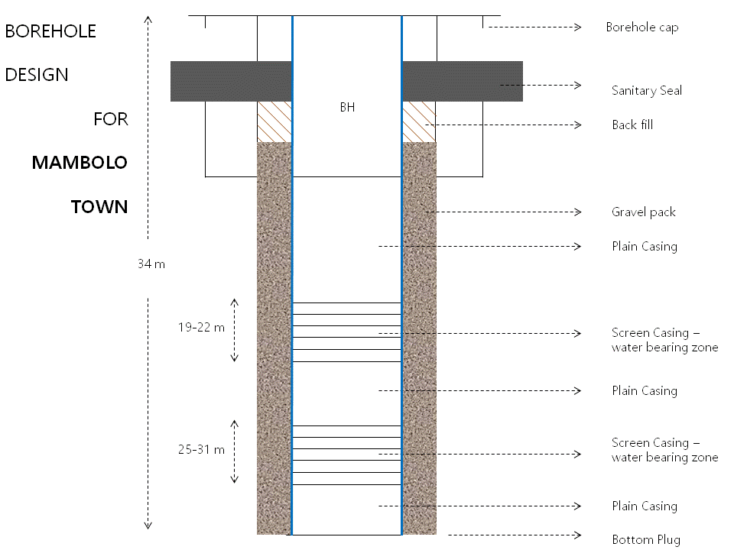
2 | 0936 | 0950 |  | 2-4 | Brown soil
3 | 1002 | 1009 |  | 4-6 | Brown clay and sand
4 | 1009 | 1017 |  | 6-8 | Brown clay
5 | 1017 | 1028 |  | 8-10 | Brown clay
6 | 1028 | 1039 |  | 10-12 | Brown clay
7 | 1039 | 1048 |  | 12-14 | Grain gravel
8 | 1048 | 1119 |  | 14-16 | Grain gravel
9 | 1119 | 1140 |  | 16-18 | Polders
10 | 1140 | 1220 |  | 18-20 | Aquifer zone
11 | 1220 | 1259 |  | 20-22 | Igneous rock
12 | 13 30 | 1415 |  | 22-24 | Igneous rock
13 | 1415 | 1448 |  | 24-26 | Ingenious rock
14 | 1448 | 1550 |  | 26-28 | Igneous rock
15 | 1550 | 1640 |  | 28-30 | Igneous rock
16 | 1640 | 1739 |  | 30-32 | Aquifer zone
17 | 1739 | 1831 |  | 32-34 | Aquifer zone

- Royark
Name of the community |  |  | Chiefdom |  |  | GPS COORDINATES |  |  | Total Depth (m) | Water Level (m) | Borehole Yield (m3) | Borehole ID (Nameplate ID)
 |  |  |  |  |  | Latitude | Longitude
Royark |  |  | Mambolo |  |  | 8°56’01” N | 12°59’49” W |  | 48m | 17.2m | 5.10m³ | 2016B0026
Formation Log |  |  |  |  |  |  |  | CASINGS PLANNING
No | Start | Finish |  | Meter | Formation Remarks
1 | 09.30 | 0939 |  | 0-2 | Brown soil |  |  | 48M-45M Plain casing  45M-39M screen casings  39M-33M Plain casings  33M-29M Screen casings  29M-26M plain casings  26M-23M Screen casings  23M-01M plain casing  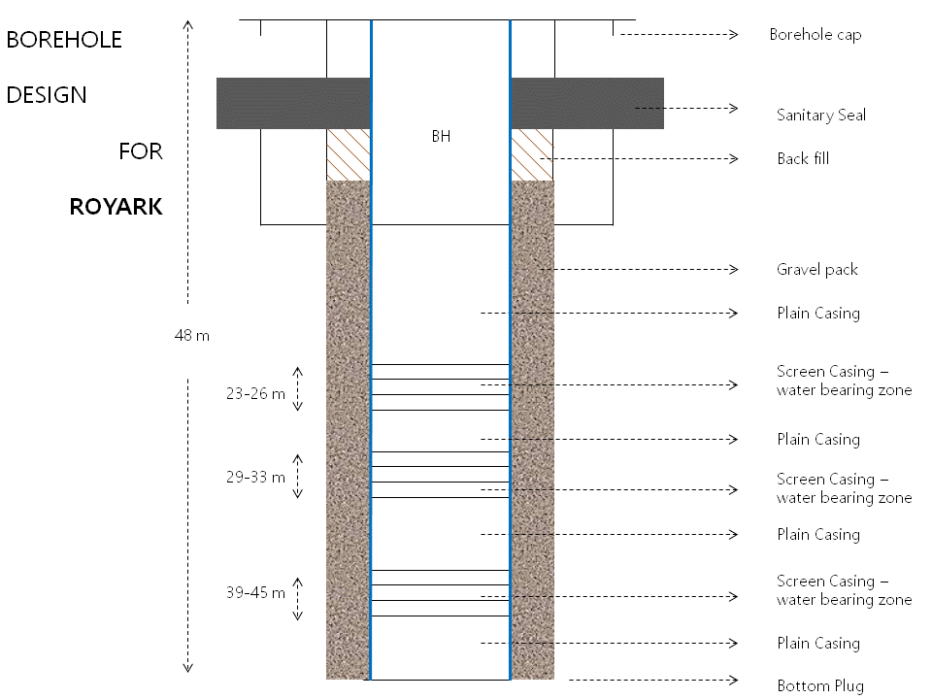
2 | 0939 | 0948 |  | 2-4 | Brown soil
3 | 09 48 | 0957 |  | 4-6 | Brown clay and sand
4 | 0957 | 1017 |  | 6-8 | Brown and clay
5 | 1017 | 10 33 |  | 8-10 | mudstone
6 | 1033 | 1039 |  | 10-12 | Weathered zone
7 | 1039 | 1048 |  | 12-14 | Dyke deposits
8 | 1048 | 1119 |  | 14-16 | Highly fractured
9 | 1119 | 1140 |  | 16-18 | Highly fractured
10 | 1140 | 1220 |  | 18-20 | Igneous rock
11 | 1220 | 1259 |  | 20-22 | Igneous rock
12 | 13 30 | 1415 |  | 22-24 | Igneous rock
13 | 1415 | 1448 |  | 24-26 | Aquifers zone
14 | 1448 | 1550 |  | 26-28 | Igneous rock
15 | 1550 | 1640 |  | 28-30 | Aquifer bearing zone
16 | 1640 | 1739 |  | 30-32 | Aquifer zone
17 | 1739 | 1831 |  | 32-34 | Igneous rock
18 | 1831 | 1921 |  | 34-34 | Igneous rock
19 | 1921 | 2017 |  | 34-40 | Aquifer zone
20 | 1020 | 1530 |  | 40-48 | Igneous rock
- Kamba Village
Name of the community |  |  | Chiefdom |  |  | GPS COORDINATES |  |  | Total Depth (m) | Water Level (m) | Borehole Yield (m3) | Borehole ID (Nameplate ID)
 |  |  |  |  |  | Latitude | Longitude
Kamba Village |  |  | Magbema |  |  | 9°10’32” N | 12°47’40” W |  | 46 | 6.5 | 5.40 | 2016B0024
Formation Log |  |  |  |  |  |  |  | CASINGS PLANNING
No | Start | Finish |  | Meter | Formation Remarks
1 | 0930 | 0938 |  | 0-2 | Brown soil |  |  | 46M-40M Plain casing  40M-38M screen casings  38M-30M Plain casings  30M-26M Screen casings  26M-01M plain casings  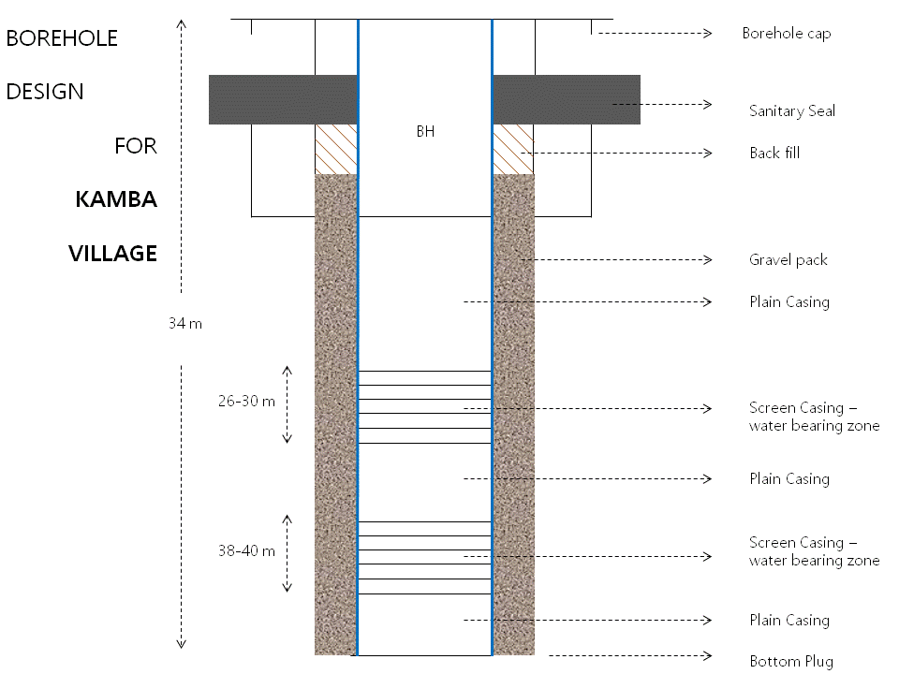
2 | 0933 | 0947 |  | 2-4 | Brown soil
3 | 0947 | 0956 |  | 4-6 | Brownish clay
4 | 0956 | 1016 |  | 6-8 | Brownish clay
5 | 1016 | 1030 |  | 8-10 | Brownish clay mixed with gray sand
6 | 1030 | 1040 |  | 10-12 | Brownish clay mixed with gray sand
7 | 1040 | 1047 |  | 12-14 | Grayish fine sand
8 | 1047 | 1105 |  | 14-16 | Grayish fine sand
9 | 1104 | 1110 |  | 16-18 | Grayish fine sand
10 | 1110 | 1130 |  | 18-20 | Grayish sand mixed with gravel
11 | 1130 | 1158 |  | 20-22 | Partially weather granite
12 | 1158 | 1225 |  | 22-24 | Partially weather granite
13 | 1250 | 1315 |  | 24-26 | Fracture weather granite
14 | 1315 | 1430 |  | 26-30 | Fracture Aquifer zone
15 | 1430 | 1510 |  | 30-32 | Granite rock
16 | 1510 | 1555 |  | 32-34 | Granite rock
17 | 1555 | 1640 |  | 34-36 | Granite rock
18 | 1640 | 1705 |  | 36-38 | Fractured granitic rock
19 | 1705 | 1730 |  | 38-40 | Fractured granitic rock
20 | 1730 | 1900 |  | 40-46 | Granitic rock

