Hydrogeology
The hydrogeology map below shows a simplified overview of the type and productivity of the main aquifers at a national scale (see the Hydrogeology map resource page for more details).
More information on the hydrogeology of Sierra Leone is available in the documents listed in the References section, below.
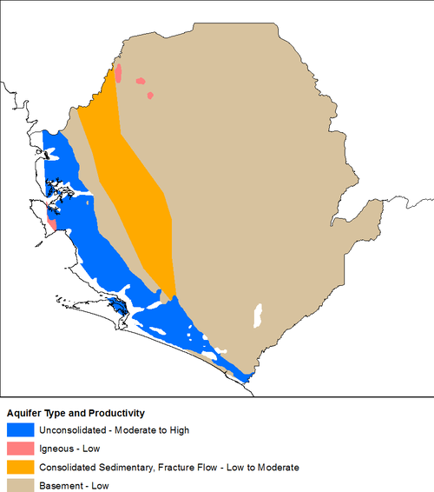
Hydrogeology of Sierra Leone at 1:5 million scale. For more information on how the map was developed see the Hydrogeology map resource page
.
Summary
The main hydrogeological distinction in Sierra Leone is between the relatively low permeability and productivity aquifers formed by the crystalline Precambrian Basement Complex, consolidated metasedimentary rocks and igneous intrusions; and the higher permeability and storage of the Bullom Group unconsolidated sand aquifer in the coastal zone. The weathered basement rocks form the most widespread and important aquifer across most of Sierra Leone.

Unconsolidated Sedimentary
Named Aquifers | General Description
Alluvial (valley fill) deposits | Sands, gravels and clays that overlying the basement rocks, usually up to 15 m thick. They can have high permeability. Groundwater storage and flow is entirely intergranular. There is little data on borehole yields, but it is likely that yields of between 0.3 and 5 litres/second (l/s) will be possible (Lapworth et al. 2015).
Bullom Group | Unconsolidated sands and clays (inland alluvial & coastal), usually 10 to 20 m thick, can form a moderately productive aquifer with potential borehole yields up to 3 l/s. Groundwater flow is intergranular and storage capacity can be high. Fracture flow is less common (Lapworth et al. 2015).  Below this are interbedded sands and clays which are typically 30 to 80 m thick. Boreholes can often abstract up 6 l/s (Lapworth et al. 2015).

Consolidated (meta)Sedimentary - Fracture Flow
Named Aquifers | General Description
Saionya Scarp / Rokel River groups | There is a near-surface weathered (regolith) layer that is often dominated by clay. Below this are ancient conosolidated (meta)sedimentary rocks, with very little intergranular porosity. Groundwater storage and flow occurs within fractures in the rock, which are often along old bedding plains, although there is little information on potential borehole yields (Lapworth et al. 2015).

Igneous
Named Aquifers | General Description
Granites, gabbros, dolerites | Fractured gabbros are thought not to typically develop a thick weathered zone. Groundwater is likely to flow through the igneous rocks largely in fractures, although thin weathered zones may also contribute. There is little information on borehole yields (Lapworth et al. 2015).

Basement Complex
Named Aquifers | General Description
There is typically a layer of highly weathered rock (regolith) overlying the unweathered bedrock, which has often transformed to a thick tropical soil. This is generally up to 20 m thick, although up to 37 m thick has been seen. The upper section of this weathered zone often has relatively little clay - the clay minerals have often been leached out, leaving metal oxides. These metal oxides are often in the form of indurated or gravelly layers, which can be highly permeable, and can allow rapid horizontal groundwater flow. Towards the bottom of the weathered zone, the weathered rock is often dominated by clays, and therefore has much lower permeability. Yields from shallow boreholes abstracting from this zone are typically in the range 0.3 to 1.5 l/s. This shallow aquifer tends to dry up rapidly when the rains stop and groundwater drains rapidly away through the permeable material. It is vulnerable to contamination, because of limited attenuation potential in the subsurface and rapid horizontal and vertical groundwater flow pathways for seasonal rainfall recharge (Lapworth et al. 2015).
At the base of the weathered zone, the underlying crystalline bedrock is often extensively fractured and not clay rich, and can store and transmit groundwater through fractures. There can also be deeper fracture zones associated with faults. The average thickness of the fractured aquifer zone is 35 m, but it can be as much as 60 m. Borehole yields are typically between 0.3 and 1.5 l/s. Groundwater flowpaths are usually longer than in the shallow weathered aquifer, and groundwater flow can be rapid over distances of tens of metres. This deeper, fractured aquifer zone is typically a more sustainable groundwater source than the upper weathered zone. It also has more potential for the natural attenuation of contaminants, because of the overlying clay zone and the longer flowpaths (Lapworth et al. 2015).

Groundwater management
Information on groundwater sources (water points) is collected in certain districts, but there is no central national database of groundwater sources. Borehole logs with geological information are not readily available.
The Salone Water Security website is the focal point for Sierra Leone’s national policies, strategies, legislation and regulation on water resources, water management and water security. It is also a repository for hydrological (rainfall, surface water and groundwater) data. The Ministry of Water Resources collates, quality controls, archives and publishes hydrometric data from gauging station networks across Sierra Leone.
The Salone Water Security website includes some groundwater level data for hand-dug wells and boreholes which were monitored during the Water Security Project from November 2012 onwards.
There is no national groundwater monitoring network, but the Salone Water Security website shows a map of a proposed groundwater monitoring network.

